**1. What is DevOps?**

DevOps is a **set of practices, principles, and cultural philosophies** aimed at improving collaboration between **development (Dev)** and **operations (Ops)** teams to enable faster and more reliable software delivery.

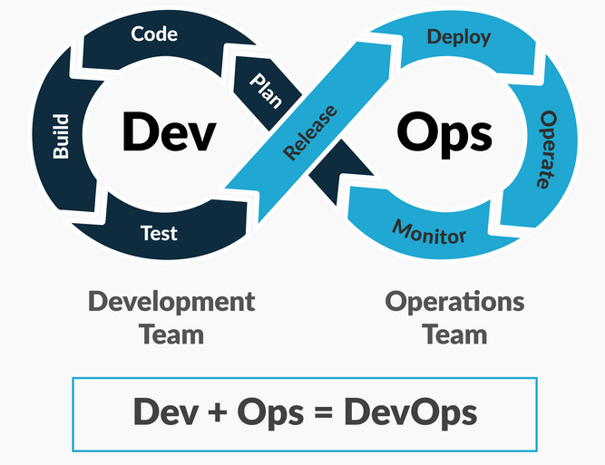

**Key Features of DevOps:**

* **Collaboration**: Breaking silos between developers and IT operations.
* **Automation**: Automating repetitive tasks like code integration, testing, and deployment.
* **Continuous Integration/Continuous Delivery (CI/CD)**: Automating code integration, testing, and deployment pipelines.
* **Monitoring and Feedback**: Continuous monitoring of performance, user feedback, and system health.
* **Agility**: Faster development cycles, testing, and deployment of applications.

**Benefits of DevOps:**

* Faster software delivery and updates
* Improved collaboration and communication
* Higher deployment frequency and reliability
* Reduced risk of failures

**2. What is Cloud?**

Cloud refers to **on-demand access to computing resources** (like servers, storage, databases, and software) over the internet. Instead of owning physical hardware or software, users can **rent or use resources** from cloud providers.

**Key Characteristics of Cloud:**

* **On-Demand Access**: Resources are available as needed.
* **Scalability**: Easily scale up or down based on demand.
* **Pay-As-You-Go Pricing**: Pay only for the resources you consume.
* **Accessibility**: Access resources from anywhere with an internet connection.
* **Maintenance**: Managed and maintained by the cloud provider.

**3. Cloud Distribution Models (IaaS, PaaS, SaaS):**

Cloud services are categorized into three main models:

| **Model** | **Full Form** | **Definition** | **Examples** |
| --- | --- | --- | --- |
| **IaaS** | Infrastructure as a Service | Provides virtualized infrastructure (servers, storage, networking) on a pay-as-you-go basis. | Azure Virtual Machines, AWS EC2, Google Compute Engine |
| **PaaS** | Platform as a Service | Provides development tools, frameworks, and runtime environments to deploy applications. | Azure App Services, AWS Elastic Beanstalk, Google App Engine |
| **SaaS** | Software as a Service | Delivers software applications over the internet. No installation or maintenance required. | Microsoft 365, Salesforce, Gmail, Dropbox |

* **IaaS**: You manage applications, middleware, and OS. The cloud provider manages infrastructure.
* **PaaS**: The provider manages everything except your application and data.
* **SaaS**: The provider manages everything, and users just use the application.

**4. What is Azure DevOps?**

Azure DevOps is a **cloud-based set of tools and services** provided by Microsoft to enable DevOps practices like collaboration, CI/CD, and agile project management. It helps streamline the software development lifecycle.

**Key Components of Azure DevOps:**

1. **Azure Boards**: Work tracking, agile planning, and project management (Kanban boards, backlogs).
2. **Azure Repos**: Source control (Git repositories) for code collaboration and versioning.
3. **Azure Pipelines**: CI/CD pipelines for automating builds, testing, and deployments.
4. **Azure Test Plans**: Manual and exploratory testing tools for ensuring quality.
5. **Azure Artifacts**: Package management to share and manage libraries and dependencies.

**Why Use Azure DevOps?**

* Supports end-to-end DevOps workflows.
* Seamlessly integrates with other tools (GitHub, Jenkins, Docker, etc.).
* Enables faster and more reliable software delivery.
* Provides scalability and flexibility for teams of all sizes.Top of Form

Bottom of Form